Sample Program which is calling progress bar

*t_msg_form.prg

public f_head,f_bar_val

f_head = 'Reindexing 1'
f_bar_val = 15

do t_progress.wfm
do t_inde.prg

f_head = 'Reindexing 2'
f_bar_val = 30
do t_progress.wfm
do t_inde.prg

clos form
retu

Progress bar form code
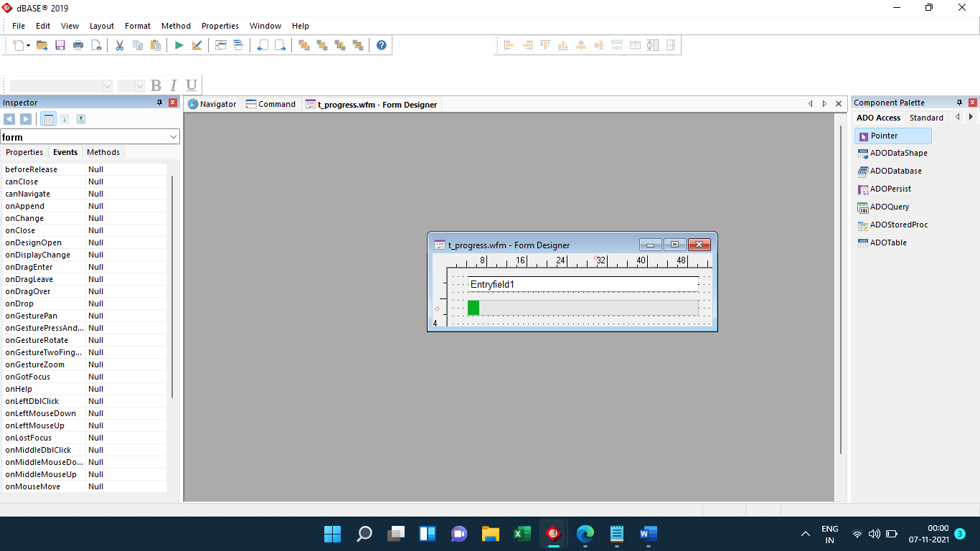

Code
** END HEADER -- do not remove this line
//
// Generated on 07-11-2021
//
parameter bModal
local f
f = new progressForm()
if (bModal)
f.mdi = false // ensure not MDI
f.readModal()
else
f.open()
endif

class progressForm of FORM
with (this)
height = 4.6364
left = 48.2857
top = 7.4545
width = 55.7143
text = "Proceesing"
topMost = true
autoCenter = true
mdi = true
moveable = false
statusMessage = "Processing"
escExit = false
maximize = false
minimize = false
endwith

this.PROGRESS1 = new PROGRESS(this)
with (this.PROGRESS1)
onOpen = class::PROGRESS1_ONOPEN
height = 1.0
left = 4.0
top = 2.0
width = 46.0
value = 5
rangeMin = 0
rangeMax = 100
endwith

this.ENTRYFIELD1 = new ENTRYFIELD(this)
with (this.ENTRYFIELD1)
onOpen = class::ENTRYFIELD1_ONOPEN
height = 1.0
left = 4.0
top = 0.5
width = 46.0
value = "Entryfield1"
endwith

function ENTRYFIELD1_onOpen()
this.value = f_HEAD
form.entryfield1.value = f_head
return

function PROGRESS1_onOpen()
form.progress1.value = f_bar_val
return

function form_onChange()
form.refresh()
return

endclass

Output not showing progress bar. However it does changes the Entryfield1 value
