Query

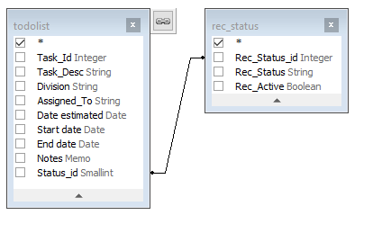

Select todolist.*,
rec_status.*
From todolist
Inner Join rec_status On todolist.Status_id = rec_status.Rec_Status_id

Based on the matchng todolist.Status_id = rec_status.Rec_Status_id want to dsplay Rec_status

